Gift Voucher for
All Five Stages of
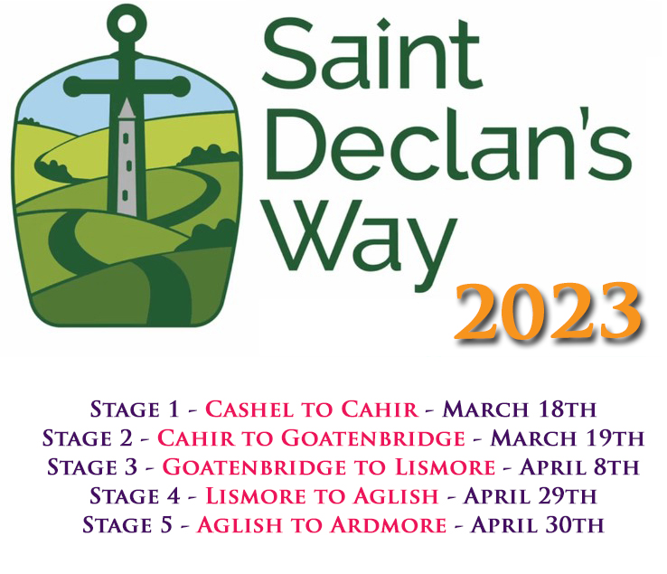

__________
From:
To:
Voucher Code:
(Enter this code when checking out after booking your place at www.StDeclansWay.ie)

Note: Booking for St. Declan’s Way 2023 will open in mid-January. Keep an eye on www.Facebook.com/StDeclansWay or sign up for updates at www.StDeclansWay.ie to be informed when booking has commenced.

Instructions
Delete this second page before converting to PDF (just use the backspace key to get rid of this text.)
Fill in the blanks in the previous page as follows:

From: Your name
To: Name of the token recipient
Voucher Code: sdw123abc (put your received code in this space above)

Note: You will receive this code via email. Copy it and paste it into the space above.

When you’ve inputted the information, delete all the text on this page, then go to File > Export and create a PDF file. This PDF can then be sent from your computer via email or printed and physically sent by post.

