Gift Voucher for
X Stages of
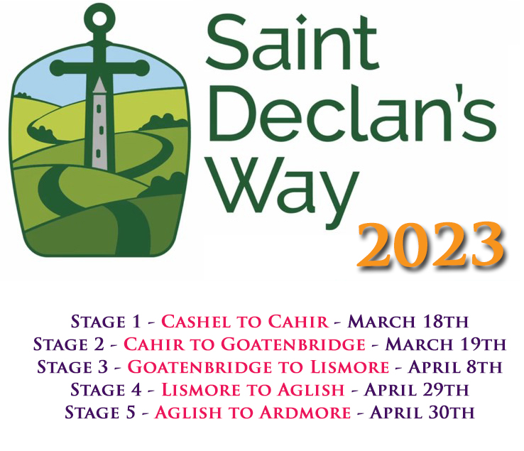

__________
From:
To:
Voucher Codes:
(Enter these codes when checking out after booking your place at www.StDeclansWay.ie. Each code will book a single stage, each one will need to be booked separately.)

Note: Booking for St. Declan’s Way 2023 will open in mid-January. Keep an eye on www.Facebook.com/StDeclansWay or sign up for updates at www.StDeclansWay.ie to be informed when booking has commenced.

Instructions
Delete this second page before converting to PDF (just use the backspace key to get rid of this text.)
Fill in the blanks in the previous page as follows:

X Stages of Replace the ‘X’ with the number of tokens you’ve purchased.

From: Your name
To: Name of the token recipient
Voucher Codes: SDW123ABC, SDW311CBA, SDW345DEF (put your received codes in this space above)

Note: You will receive these codes via email (each one will come in a separate email, so you’ll have a different code for each stage), copy them and paste them into the Voucher Codes space above.

When you’ve inputted the information, delete all the text on this page, then go to File > Export and create a PDF file. This PDF can then be sent from your computer via email or printed and physically sent by post.

